Linear search:

1.

#include<stdio.h>

int main()

{

int a[100],i,search,n;

printf("Enter the number of elements?");

scanf("%d",&n);

printf("Enter array elements:");

for(i=0;i<n;++i)

scanf("%d",&a[i]);

printf("Enter element to search:");

scanf("%d",&search);

for(i=0;i<n;++i){

if(a[i]==search)

break;

}

if(i<n)

printf("Element found at index %d",i);

else

printf("Element not found");

return 0;

}

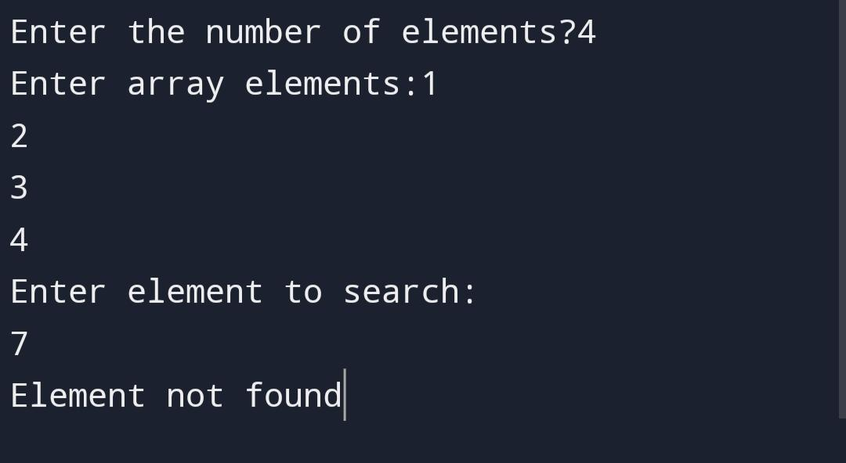

Binary search:

2.

#include <stdio.h>

int main()

{

int i, low, high, mid, n, search, array[100];

printf("Enter number of elements:");

scanf("%d",&n);

printf("Enter %d integers\n", n);

for(i = 0; i < n; i++)

scanf("%d",&array[i]);

printf("Enter value to find:");

scanf("%d", &search);

low = 0;

high = n - 1;

mid = (low+high)/2;

while (low <= high) {

if(array[mid] < search)

low = mid + 1;

else if (array[mid] == search) {

printf("%d found at location %d.\n", search, mid+1);

break;

}

else

high = mid - 1;

mid = (low + high)/2;

}

if(low > high)

printf("Not found!. %d isn't present in the list.", search);

return 0;

}

